Charting the course of innovation:A startup analysis

1.Introduction;

A startup analysis is essential to the success of any startup business. It allows enterpreneurs to identify the key areas that need improved and make necessary changes early on.Doing a startup analysis also allows startups to track their progress and ensure that they are on track to achive their goals.

2.Problem Definition & Design Thinking ;

Empathy map:

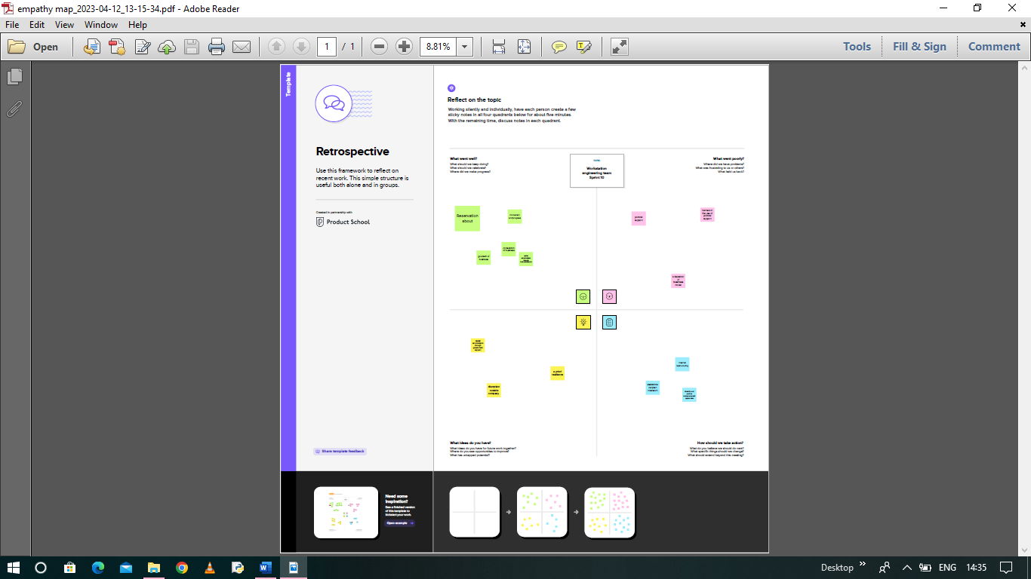

Brainstorm;

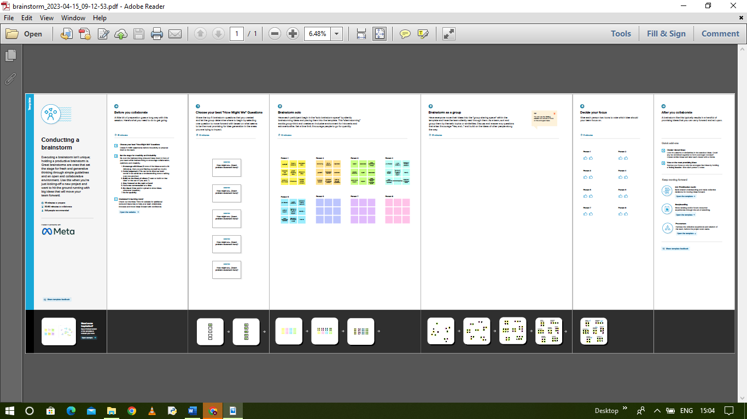

3.Result;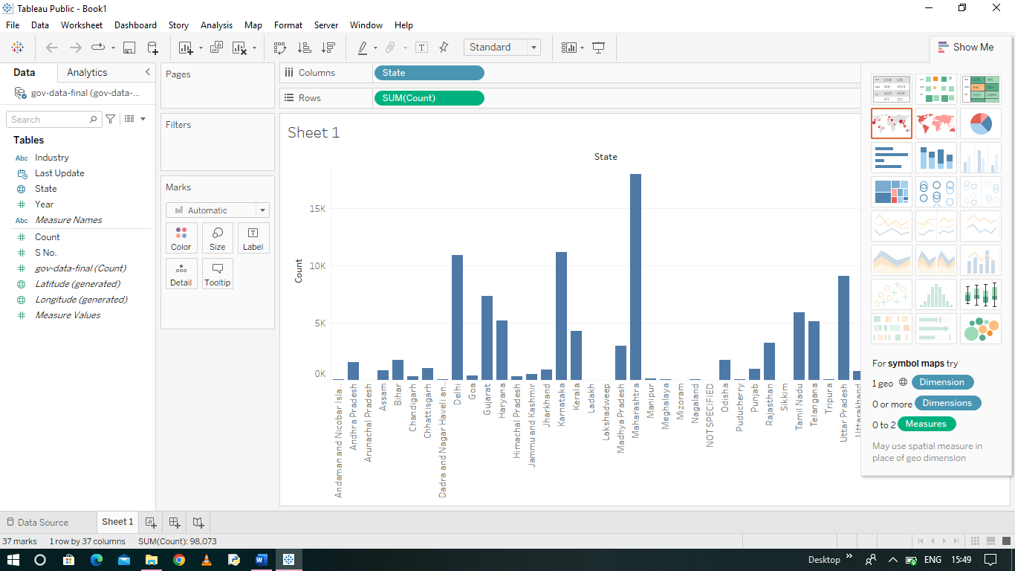

4.Advantages & Disadvantages;

Advantages:

1. Agility 4.Personalization
2. Efficiency 5.Versatility
3. Team culture 6.Having fun

Disadvantages;

1.Risk of failure 4.Team conflicts

2.Low of compensation 5.Lack of resources

3.Poor market access 6.Stressed out

5.Applications;

1.Market data can be inaccurate

2.Market data can be expensive

6.Conclusion;

The best way to learn is to do it in action.Just select an industry and follow above steps to do the analysis in reality.

7.Future Scope;

In addition, startups continue to bring innovation and disruption in multiple industries.